Final Report

2003 Reduced Gravity Student Flight Opportunities Program

Gr.A.I.N.S. II
Granular Agglomeration in Non-gravitating Systems
Experiment 2003-190

August 1, 2003

The University of Tulsa Granular Dynamics Group
Department of Physics and Engineering Physics
The University of Tulsa
600 South College Avenue
Tulsa, OK 74104

Research team:

Justin Mitchell, Aaron Coyner, Adrienne McVey, Rebecca Ragar, Jeffrey Wagner,
Justin Eskridge, Ian Zedalis, Erin Lewallen, and Nathan Jordan

Graduate Student Advisor:

Matthew Olson
Department of Electrical Engineering
University of Tulsa

Faculty Advisor:

Shawn Jackson
Department of Physics
University of Tulsa
I. Technical Aspects

Experimental Abstract
Recently, a great deal of effort both in industry and academia has focused on studying the interactions within and overall behavior of granular systems (Jaeger). Of particular interest have been studies of ‘gases’ of macroscopic objects such as ball bearings, dust, soot, etc. Theoretical models have predicted (Grossman) and some experiments have shown (Maddox) that a gas of balls tends to form clusters when the gas is undisturbed by external influences such as gravity. Clustering is the consequence of energy dissipation due to inelastic collisions between balls. The continued dissipation of energy leads to inelastic collapse, where two or more balls lose all relative motion (McNamara and Young). The behavior of such clusters appears to be dependent on driving parameters, particle densities and the coefficients of restitution of the balls. The motions of individual balls have been analyzed in two-dimensional granular systems. Analyses have not yet been performed on three dimensional systems. The only three dimensional experiment performed was on a set of relatively dense granular systems (Falcon). The density was high enough that correlation could not be made between collapse of the gas, particle energies, input energies, and effective gas pressure.
The question of collapse has particular importance for a description of the dynamics of interstellar dust clouds and planetary ring systems (Jaeger). Measurements of asteroid densities have shown that objects less than about (1 km³) in volume have densities on the order of 1-1.5 g/cm³ (Yeomans). At these densities, an object 100 meters in radius has an escape velocity of
~10 cm/s. With such small escape speeds these objects are not able to gravitationally accumulate mass and thus are not able to accrete dust and grow in size. Inelastic collapse, if it were shown to occur in dilute dusty systems, would provide a means for the formation of these moderately sized objects.
In this research project we look for the occurrence of clustering and inelastic collapse within driven granular gases that are in a low gravity environment. We also examine how driving parameters affect the configuration of granular systems, namely, granular gas, clustering within granular gas, and inelastic collapse of granular gas. This project utilizes an apparatus built by our group at the University of Tulsa. We have made initial arrangements for our apparatus to fly aboard a NASA Space Shuttle.

Test Procedures
Due to the difficulty of manually carrying out complicated experimental procedures in a microgravity environment, and since this experiment will eventually fly aboard the Space Shuttle via the Get Away Special Program, the apparatus was designed to facilitate a highly-automated data collection process. During the actual flight, crew members were responsible for powering up experimental equipment before the first zero-g maneuver, pressing a button before each zero-g maneuver to advance between experiments, and powering down the experiment upon the completion of the last parabola, in addition to dealing with any unforeseen problems. Additionally, because minor plane accelerations during weightlessness were greatly amplified in our experiment during the July 2002 flight, we opted to have a free-floating experiment this year, thereby allowing the balls to float in a more thoroughly weightless environment. The following list describes the procedures followed before, during, and after both flights.

Pre-Flight
- Verify all experimental systems functioning properly:
  - DC shaker motor
  - Stepper motor
  - Shaker system
  - Lights
  - Camera
  - User interface
  - Power supply
- Verify proper optical alignment of cameras and mirrors.
- Change video tapes (Flight day 2 only).

Flight
- Retrieve power supply from stowed position and strap down with RGSFOP-provided straps.
- Connect power supply to experiment and turn on.
- Power up experiment.
- Use IR remote to start camcorders recording.
- Approximately 10 seconds before entering microgravity, depress NEXT button to advance to experiment 1. Microcontroller runs the preprogrammed experiment 1.
- For each subsequent maneuver, approximately 10 seconds before microgravity entry, depress NEXT button to advance to the next experiment.
- During the microgravity portion of each maneuver, unstrap the experiment and allow it to free-float
- Following last microgravity parabola, power down experiment.
- Turn off power supply and disconnect from experiment.
- Unstrap power supply and return to crash-proof box for landing.

Post-Flight
- Review collected data.
- Note any deviations from planned data collection.
- Note any problems with experimental apparatus or procedures.

We ran the same set of experiments during each parabola on both flight days.

Data Collection and Test Results

Brief Review of Apparatus
The experimental system in the GrAINS apparatus consists of a box separated into eight chambers of equal volume (~ 1 in³), each filled with a different number of brass ball bearings. The box is shaken along a body diagonal at various amplitudes and frequencies. Piezoelectric pressure sensors collected information about ball collisions into one wall of each box. Our sensors consist of a 1mm thick sapphire plate epoxied to one side of an APC-850 piezoelectric disk. A 1 mm thick lead sheet is epoxied on the opposite side of the disk. The lead acts as a rigid surface ensuring that impacts to the sensor will cause deformation of the disk and not movement of the entire sensor assembly. Epoxied to the lead sheet is a 1.5 mm thick layer of foam rubber that is in turn glued to the aluminum support frame. The rubber and lead act as a damped oscillator and were selected to attenuate high frequency mechanical impulses present in the aluminum frame. In this fashion, balls impacting the sapphire plate cause deformation in the piezoelectric disk resulting in a measurable voltage spike.
Impact data were recorded by electrically connecting the piezoelectric disks to a microprocessor and an analog-to-digital (AD) converter. The AD converter allows the data to be recorded as four bit hexadecimal readings onto a 6.4 GB hard drive for each flight day. For the purposes of measuring the impact voltage due to single collisions, each sensor’s signal were amplified through a standard inverting op-amp circuit to increase the output voltage. The gain of the op-amp circuit has a measured value of 1000. A schematic of the op-amp circuit is shown as figure 1.

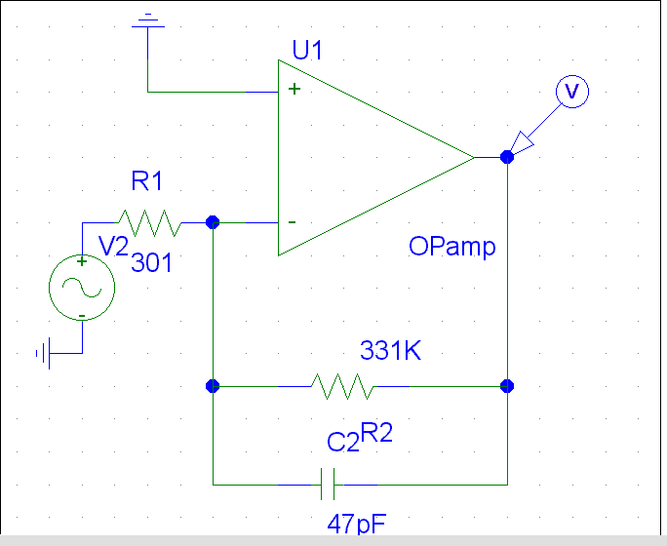
Figure 1: Schematic of the amplifier circuit used in the GrAINS II experiment

Digital cameras collected video information about the dynamics of the balls. A WayCon series SM 12mm linear variable displacement transducer (LVDT) was used to monitor the amplitude of the oscillating box. An Analog Devices ADXL202 accelerometer chip was used to monitor the acceleration of the apparatus and to discern the time intervals of low gravity. The computer hard drive recorded the LVDT and the accelerometer data.

Data Collection and Preparation
Eight sets of impact data were recorded during each flight parabola. Each set of impact data corresponds to a specific impact sensor and test chamber within our box. The packing statistics are included in Table 1.
Table 1 : Cell Packing Statistics
Cell | Number of Balls | Cell | Number of Balls
1 | 254 | 5 | 1120
2 | 385 | 6 | 3422
3 | 770 | 7 | 3487
4 | 1283 | 8 | 0
Once back on the ground, our data were transferred to our laboratory computer. A data extraction program was designed to take the hexadecimal output of the raw data and convert it to actual voltage reading. The analog-to-digital converter records voltages from 0 to 5 volts; however, for the purposes of FFT analysis, the data had to be scaled from 0 to 1 volt in order to work with our SpectraPlus FFT Spectral Analyzer software. The QBASIC data extractor program scaled the data so that the FFT analysis could be performed on all the channels.
The video data sets were read off digitally via each camera’s firewire port and stored in .avi format. The .avi files were converted into a series of bitmap files, which are being analyzed using software we are developing with the Interactive Data Language (IDL). All data were recorded and processed using the same sequence of steps.
The audio data contain impact information and are analyzed using techniques such as fast Fourier transforms. We hope to extract values of granular pressure from these data. The video data will be used to assemble velocity distributions. From these distributions we hope to extract values of granular temperature. We will also study how the pressure and temperature scale with the driving parameters.

Analysis Procedures and Results

Flight Data from Spring 2003 KC-135 Flight Campaign

The data we wish to analyze must be those recorded during the low gravity portion of the flight maneuver. Sadly, our accelerometer malfunctioned and it yielded no meaningful data. We are currently in the process of discerning the low gravity time intervals by visual tracking of balls in the video data. Low gravity time intervals should be characterized by the inertial trajectories of balls between collisions, i.e., by balls that move in nearly a straight line with constant speed. This work is ongoing.

a. Audio data
Data from the piezoelectric sensors were sampled at a rate of 1 kHz. Testing has shown the sensors have a decay time constant of about half a millisecond. Since the time between two samples is twice the decay time constant, the effects of an impact on the sensors should not last long enough to significantly affect more than one sample. The forced oscillation (used to impart energy to the balls) of the boxes is expected to affect the measurements taken by the piezoelectric sensors. Since the boxes were shaken as a unit, the effect of vibration should be the same for each box. The sensor data from the empty box will be used to subtract out this effect. Shown in figure 2 is an excerpt of the LVDT data superimposed on data from box 1 collected during the same time interval. The LVDT signal is shown in black, and the data for box 1 is shown in white.

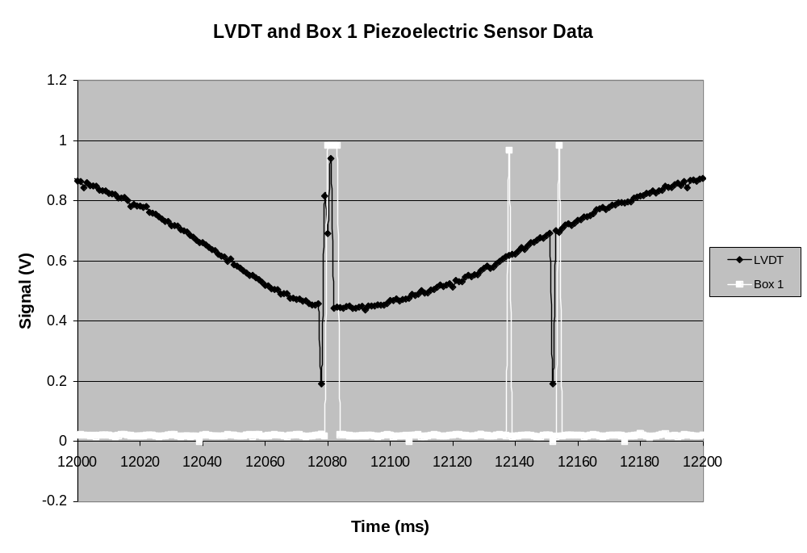
Figure 2: Excerpt of audio data displaying errors and the signature of a possible impact event can be seen.

The LVDT signal (black) should be nearly sinusoidal. The two regions of jumps in the LVDT signal are evidence of data recording errors. The LVDT and piezoelectric sensor data were recorded with the same device, so the jumps in the signal from box 1 (white) near the regions of known recording error are also assumed to be errors. One of the jumps in the signal from box 1 does not correspond to a jump in the LVDT signal. The isolated jump is likely the result of an impact event. This hypothesis is currently being tested in the hope that the time and force of impacts can be determined. Information about the impacts which occurred might make possible a calculation of the granular pressure in each box as a function of time.
Once the low gravity time intervals are discerned, we will analyze the audio data from those intervals. We will perform fast fourier transforms on the data in order to look for sources of noise in the data. Once we have audio data that are as noise free as possible, we will look at impact amplitudes as a function of time. From this we hope to extract a value of the granular pressure in each of the test chamber cells. In particular, we will look at how the granular pressure scales with the maximum velocity of the shaken test chamber for instances of granular gases and also for clustering. In this way we hope to learn how the driving parameters affect the evolution of the granular dynamics.

b. Video data
A considerable amount of video data was acquired during this campaign, and the data were far superior to those collected during the July 2002 campaign. Figure 3 is an example frame from the video. We did experience some difficulties, which will be discussed later. There are two main goals for this video information. The first is to find a velocity distribution of a collection of brass balls shaken in a microgravity environment. The second is to show inelastic collapse within the collection of balls. The collapse is theorized to be a clumping of macroscopic particles due to many successive inelastic collisions and could be a factor in the formation of planetary rings, asteroids, comets, planets, avalanches, sand dunes and may other granular ensembles.
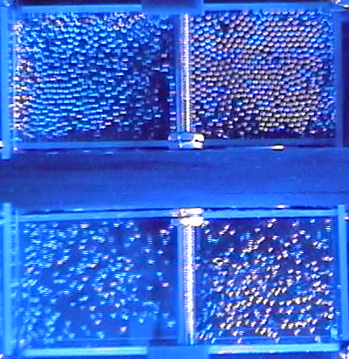
Figure 3: Frame taken from digital movie file. Some balls are obviously hidden because the system is three-dimensional.

The velocity distribution is scientifically interesting because it relates to the notion of a granular temperature. Were we considering a system of two balls or a system of 10²³ balls we would already have sophisticated theoretical models to describe the system’s behavior. In our system, on the order of thousands of balls, we cannot make all the statistical simplifications of gaseous behavior nor can we make simple collision arguments for every ball. A velocity distribution function would be a crucial step in describing these sorts of systems, and in ascribing a temperature to them.
We are working to achieve our particle tracking and velocity distribution goals. The ongoing video analysis employs the Interactive Data Language (IDL). This programming language is commonly used for video analysis and includes built-in routines to assist particle finding. However, difficulties with the IDL program used to find and track balls have slowed our analysis of the video data. Nonetheless, we currently have the ability to find balls in a given video frame, but the accuracy is not yet known. Figure 4 is a close up of the lower right chamber. The coloring and contrast of this image have been adjusted using Adobe Photoshop to make the balls easier to see and easier for IDL to find. The IDL program creates contour images of the ball images in each video frame. Figure 5 is an example of contour images viewed using Adobe Photoshop. The IDL program then finds the centers of these contour images, which we estimate as the locations of the centers of the balls. Combining the ball location information from successive video frames will allow us to find two of the velocity components of every ball in the frame at any time during the video. A histogram of these velocity components constitutes a graph of the velocity distribution.

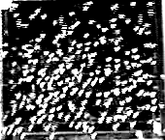

Figure 4: This image of the lower right box in figure 4 has been adjusted to increase contrast. The balls are much easier to see now and focusing has less of an effect.

We have considered the limitations of this method of finding velocity distributions. We can find only the velocity components of the balls in a reference frame attached to the box. A complete speed distribution will require viewing each chamber with at least two cameras. It will be a challenge to correlate ball images from two different cameras. Balls can easily obscure each other. The fastest balls near the outside walls are likely to obscure the slowest moving balls in the system. Additionally, while our cameras were better focused than they were during the 2002 flight campaign, we still had some difficulties with blurry images. Overall, however, the quality of the video data collected during the 2003 campaign will make the data analysis more meaningful than was the case for the data collected during the 2002 campaign.
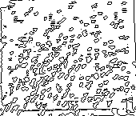
Figure 5: This is a contoured image of the lower right box in figure 4.

c. Clustering
Most importantly, we have been successful in observing clustering in three dimensional granular gases. During two parabolas in particular, this collapse can be observed in the upper two more densely packed boxes in Figure 6.

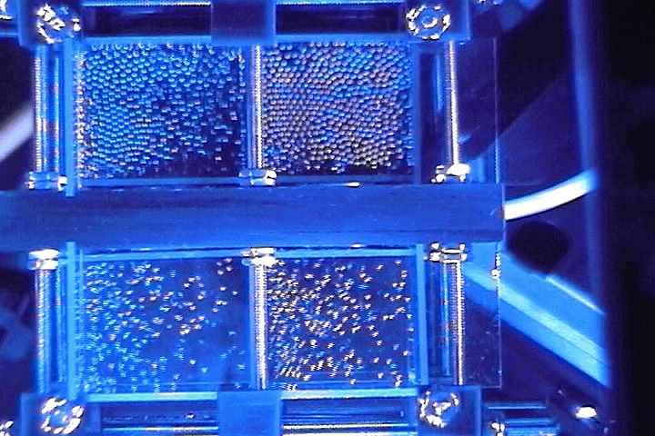
Cluster →

Figure 6: In the upper left hand cell is an illustration of clustering in a driven granular in a low gravity environment.

Problems with Data Analysis
a. Audio Analysis
Analysis of the audio data was riddled with unforeseen challenges. Numerous electrical problems complicated efforts to make sense of the data. An accelerometer was included in the apparatus so that low gravity time intervals could easily be identified. The accelerometer appears to have been functioning properly during the first parabola of day one. However, during all other parabolas the accelerometer malfunctioned. As a result it will be much more difficult to determine the time intervals during which the experiment was actually in low gravity. The cause of the accelerometer malfunction has not yet been determined. Because verification of low gravity time intervals is essential, other methods of finding the acceleration are being considered. The most promising involves tracking individual balls and watching for inertial behavior.
Another problem with the acceleration data stems from the computer program used to record the data. Data were recorded at a constant rate except while the program was resetting the internal counter it used to keep track of the data. How often this interruption occurred and how many data points were missed are not yet known. This problem is more serious than simply not having values for the acceleration at particular times. A series of about 20 data points must be considered together by the accelerometer to determine the acceleration at one point in time. So missing a data point changes a calculated acceleration value. Consequently, the uncertainty of values measured by the accelerometer is greatly increased.
The same program was used to record the LVDT and pressure data, so data points were sporadically missed in these data sets also. However, the programming alone can not account for all of the anomalies in the LVDT and pressure data. An unidentified electrical problem seems to have been present. The existence of this electrical problem is evident from regions of very high activity in the data. An example is shown in Figure 7, which displays the signal from the LVDT and all eight box chambers during the same time interval.
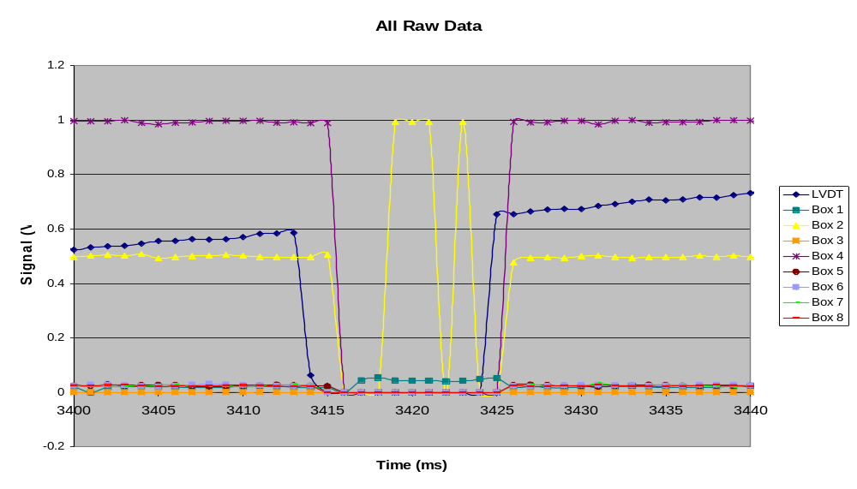
Figure 7: Superimposed signals of the LVDT and all box chambers. The abrupt change in the signals on all channels likely indicates a recording error.
The signals from all nine channels change drastically during the same time interval. The change even includes the LVDT and the empty box, so it could not be the result of ball impacts. Although the region in Figure 8 clearly does not yield valid data, smaller errors may be difficult to distinguish from impact events. The possibility that an error may affect only one data point of one channel can not be discounted. Work is being done to determine which data represent errors and which represent impacts.
The data from each channel were recorded into certain locations in the memory. When analysis began, it was apparent that the channels did not correspond to the boxes to which they were intended to correspond. The data have been used to match the boxes to the corresponding channels. Confirmation that the boxes and channels have been properly matched has been delayed because the experiment’s power supply is malfunctioning. The power supply has been sent to the manufacturer for repairs. After it is functioning again, work will begin to uncover the cause of the switched channels.
The data from most of the box chambers have baselines near zero (as expected); however, the data from two chambers do not. Chamber number two’s baseline is near 2.5 V, and chamber five’s baseline is 5 V or higher (5 V was the maximum voltage the sensor was programmed to measure). The jumps in chamber five’s signal (some of which are thought to represent ball impacts) are oriented down instead of up. Some of the jumps in chamber two’s signal are oriented up and some are oriented down. The reasons for these unexpected results are not yet known. A reversal of the polarity of the piezoelectric sensor may be the cause of the upside down signal from chamber five, but this idea has not yet been tested.
The behavior of the piezoelectric sensors when impacted may be more complex than originally anticipated. A more accurate model of their behavior may include nonlinear effects and require more sophisticated techniques to analyze the data. As an example, the piezoelectric sensors have been observed to produce a much stronger signal when struck near the edges. The voltage across a sensor (due to an impact) has also been observed to leak off. On average, a sensor loses 63 percent of its original voltage in 0.552 milliseconds. Work is ongoing to calibrate the sensors.

b. Video Data Analysis
Upon analysis of the video data collected during the flight, some significant problems became evident. Although our lighting system was greatly improved from the 2002 flight campaign, the lighting of certain camera views, particularly the side of the box seen by camera 1, could be enhanced in several ways. The lighting for camera 1 was dimmer than anticipated, allowing fewer ball bearings to be seen from this view and diminishing our ability to track them through a number of frames. The first and most obvious means of improving the lighting is by adjusting the position of one or more of the lighting mounts inside the apparatus. Because two of the camera views are well lit, this modification would most likely involve moving only one of the light mounts, but the effects of such a change would be enormously useful for data collection. A second possible means of improving the lighting would be to alter the brightness of the LEDs. Currently LEDs of two degrees of brightness are being used, but further tests may reveal that one type is more effective than the other. Future tests will be able to determine the best way to maximize the lighting within the apparatus.
Even more problematic was the issue of camera focus. For each camera on both days, certain images appear blurry. Camera 2 was not in focus during any portion of the flights on either day. The lack of focus in the images recorded using camera 2 can be seen in Figure 8 below:

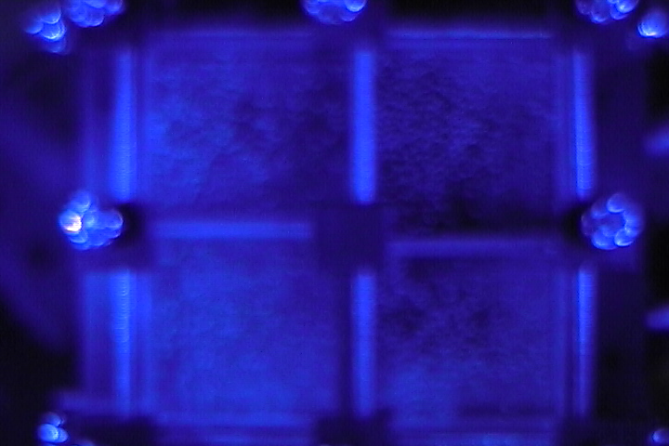
Figure 8s: A still taken from the video of Camera 2. The blurriness in this image prevents individual balls from being distinguished.

This focusing problem is such that individual balls in these images cannot be discerned either visually or by our software, and thus, with one of our cameras malfunctioning in this way, a minimum of one-third of our visual data is useless. The cause of this focusing problem is not yet known, but further tests will allow us to experiment with different settings on the cameras and determine which will bring about the sharpest focus in our images.

Continuing Work
The analysis of the audio data is ongoing. We are working to calibrate the piezoelectric sensors in order to extract granular pressure values from the impact data. We are examining the stability of our sampling rate to gauge the reliability of the impact data. We will correlate granular pressure to the maximum velocity of the shaker table in order to examine which driving parameters lead to granular gases and which lead to clustering and inelastic collapse.
The analysis of the video data is also ongoing. We can now find and track balls, and the next task is to measure their velocity components. We have most of the software written to do this and will be making progress towards the goal of establishing velocity distributions and, ultimately, speed distributions.
We are looking into the electronics problems that plagued our data. In particular, we will concentrate on the accelerometer and seek reliable means to acquire the requisite acceleration data. We will search for accelerometers that are more reliable. Currently, we are using the video data to find time intervals of low gravity by tracking individual balls and recording those time intervals during which the motion of the balls is inertial. The motion of a ball is inertial whenever it travels in a straight line at a constant speed, and we have thus far been able to find a time interval of very low gravity in parabola 14 of flight day 1 using this method. We have therefore found ball tracking to be an alternative (and tedious) means of estimating time intervals of low gravity in the absence of accelerometer data, and work in this area is continuing.

OUTREACH
One of the goals of the GrAINS outreach program is to share with the Tulsa community, as well as others via the World Wide Web, the scientific findings of the experiment, as well as the unique experience provided to team members by NASA’s Reduced Gravity Student Flight Opportunities Program. The GrAINS team has made a number of presentations and local media appearances.

In the interest of documentation, an “electronic scrapbook” CD with outreach presentations has been included with this report. A VHS video tape scrapbook of local media coverage was compiled and included. The contents of the electronic scrapbook are as follows:
February 3, 2003 | Presentation to Engineering Society of Tulsa
April 9, 2003 | Presentation to AAAS meeting; Video analysis
April 9, 2003 | Presentation to AAAS meeting; Audio analysis
April 16, 2003 | Presentation to University of Tulsa Astronomy Class (PHYS 1093)
June 21, 2003 | Presentation to Mid-states Regional Astronomy Convention

All team members have been involved in presentations. During these presentations, we describe the experiment, display and explain the function of the apparatus, discuss the scientific findings, and show video footage of the flights. In addition, members of the flight crew are able to share their personal experiences aboard the KC-135. While the basic format of all the presentations is similar, they are tailored to the age and scientific background of the particular group. For example, when talking to children, team members do a demonstration with a large-scale mock-up of the experiment to help the children gain a better understanding of the underlying scientific concepts. The following table lists the presentations completed to date.

2003 Flight Campaign Presentations and Events
Date | Event | Audience (Attendance)
02/03/03 | Engineering Week | Students and Professional Engineers (60)
02/16/03 | Engineer Shadowing Day | Students and Professional Engineers (45)
04/09/03 | AAAS meeting presentation of video | Scientists and Students (20)
04/09/03 | AAAS meeting presentation of impact data | Scientists and Students (15)
05/09/03 | Boy Scout Troop 22 meeting | Scouts and Scout Leaders (30)
06/21/03 | Mid States Regional Astronomy Convention, University of Tulsa Campus | Amateur Astronomers and Educators(75)
Fall 2003 | University of Tulsa Astronomy Class | University Undergraduates (~40)
The presentations to the Tulsa Engineering Society for both Engineering Week and Engineer Shadowing Day allowed the team to educate fellow science and engineering students about the experiment and the remarkable opportunity provided to undergraduates by the RGSFOP. Also, because of the engineering backgrounds of both the students and their mentor engineers, the presenters were able to go into some detail about the scientific background, as well as the preliminary results, of the experiment.
The presentation to the Boy Scout Troop allowed the team to bring the excitement of science and engineering to young students. The presentations to the Mid States Regional Astronomy Convention allowed the team to speak to amateur astronomer as well as educators from surrounding schools. The hope is that these presentations will excite teachers and provide them with material relevant to space science to discuss in the classroom.
Presentations to professional societies are another key part of GrAINS outreach. Two team members, Justin Mitchell and Aaron Coyner, gave 15-minute oral presentations about various aspects of the GrAINS project at the American Association for the Advancement of Science (AAAS) Southwest and Rocky Mountain Division Meeting. At the meeting, they discussed the design of the apparatus and presented the preliminary results of the experiment.
The project has been covered by news stories that have aired on local TV stations during the 6pm and 10pm broadcasts. Several of these stories occurred before the flight days and focused on the purpose of the project and what we were doing to build and test our apparatus. The final news stories, documenting our trip to Houston and our experiences during the flight campaign, were presented by our team journalist Rebecca Seebirt of KJRH-TV, the Tulsa NBC affiliate. These reports can be viewed in our video scrapbook.
The spring 2003 flight campaign took place late in our spring semester. When we returned to campus, we had to concentrate on final exams and senior theses. For this reason, we did not have opportunities to speak to students at local schools. We plan to give presentations at various local elementary, middle and high schools in the fall semester of 2003.

The project website is regularly updated with the most current information about the experiment. Contents include the text from Tulsa World newspaper articles, links to photographs of pre-flight activities and the flights themselves, and a link to a short article about the experiment on the University of Tulsa website. In addition, an entire page is devoted to outreach, listing the presentations already completed as well as team member contact information for any groups interested in a presentation. The website URL is: http://www.granular.utulsa.edu/GRAINS.html.

IV. High School Outreach Program at Union Public Schools in Tulsa, Oklahoma
For the spring 2003 campaign, the GrAINS team assisted the Tulsa Union Public Schools Young Astronauts Program (TUPSYAP) in the design, construction, and testing of an experiment that studies the two-dimensional random walk behavior of brass balls in a low gravity environment. The TUPSYAP experiment flew along side our experiment (GrAINS) during the spring 2003 campaign. Their analysis is ongoing and will resume in earnest when the school year begins in August. The following two subsections contain excerpts of the ongoing work that is being undertaken by the high school students.

A. Excerpt from Data Analysis
A copy of Microsoft Paint that has been modified using Microsoft Visual C++ Learning Edition to use a round target shaped cursor with the drawing tool as opposed to the original pencil shaped cursor, is used to mark each brass sphere in each frame with a distinct red dot on the pixel that is determined to be the center of the sphere.

After the spheres have all been marked a point of reference is marked within the frame and is used to provide a relative measurement in order to eliminate inaccuracies caused by the camera shifting or swaying. To acquire a measurement of the relative position of a ball we use the selection tool in Microsoft Paint to make a selection between the marked pixels on the desired sphere and the marked reference point being sure that each mark is positioned exactly on adjacent corners of the selected area. The selected area is then copied into to a new picture and the size of this new picture is then recorded as the position of the ball.

An Excel spreadsheet is used to record the positions and a formula [=((SQRT((X1-X2)^2+(Y1-Y2)^2))/48)/(1/30)] is used to automatically calculate the horizontal speed of the balls. The speed values are then rounded to 1 decimal place and sorted according to similar speeds. The totals of similar speeds are then compiled into a histogram chart that can be found on the 3rd sheet of the attached excel document.

The trend at this stage in the analysis according to the currently analyzed data favors a speed of 0.625in/sec. Given approximately 12x12 pixels per sphere the exact center of the sphere does not always fall in the center of a pixel and as a result we can only measure movement to the nearest pixel giving a minimum apparent speed of 0.625 in/sec. As our analysis continues we will investigate the possibility of averaging surrounding data values to yield less “choppy” speeds.

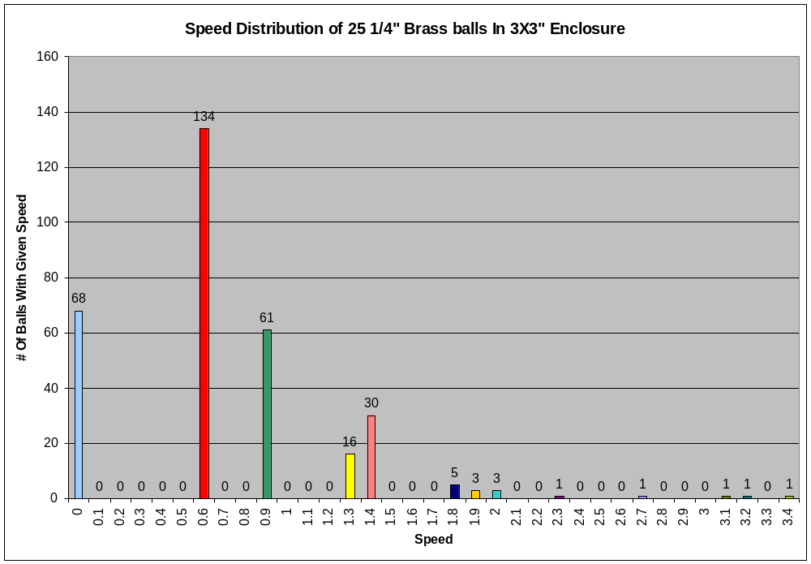
B. Excerpt from Progress Report
A Sony DCR-TRV 90 was used to collect digital video of ball movement in zero gravity, which was then broken down into individual frames. Balls were tracked one at a time using Microsoft Paint to view the frames. Each ball was tracked and speed was recorded using and X and Y co-ordinates of pixels. With the data that has been collected so far, the balls tend to move in a parabolic shape. Only the group of 25 balls has been tracked so far. Future analysis will include tracking of all balls in all groups to determine if packing density plays a part in ball movement in reduced gravity. We intend to enter this experiment in a science and engineering fair in the future. An exhibit featuring our experiment will also be built for the Tulsa Air and Space Museum to share what we have found with this experiment. At least one presentation about this experiment will be given to the 8th grade Young Astronauts and/or science classes during the next school year.

V. References
1. Falcon,V , R. Wunenburger, P. Evesque, S. Fauve, C. Chabot, Y. Garrabos, and D. Beysens.
Physics Review Letters. Vol. 83, 1999. 440.
2. Jaeger and Nagel, Review of Modern Physics, Vol. 68, No. 4, October 1996.
3. Maddox, John. Nature. Vol. 374, 1995. 11.
4. McNamara, S. and W. R. Young, Phys. Rev. E 53, 5089 (1996).
5. Yeomans, D.K., J.-P. Barriot, and B.G. Williams. Science. Vol. 278, 1997. 2106.

